Pokémon Builds Project Plan

# Project Idea

While many RPG-style games have websites where users can post and view each other’s team and character builds, Pokémon does not have a site dedicated to this function. We aim to rectify this error by building a web application that will allow users to submit their builds for Pokémon and view other users’ builds, as well as view summaries about different Pokémon, such as their types, moves, and abilities.

# Functional Requirements

Our application will allow a user to search for a Pokémon by name and view its statistics, view user-submitted builds, and submit their own builds, which are then stored and can be viewed by others.

# Architectural Design

Our application will have three webpages, each defined by an HTML document: a page for viewing summaries of searched Pokémon, one page for viewing user-submitted builds for searched Pokémon, and a page for the user to submit their own builds. The summary page will use JavaScript functions to allow the user to input text to search for a specific Pokémon, AJAX to request data from PokéAPI, an API that supplies such data as a Pokémon’s type(s), abilities, moves, and other information, and JavaScript again to format this data into a viewable form. The view page will again allow the user to search for a Pokémon by name, but this time, it will send a query to a NodeJS server, which will in turn interrogate a MySQL database for user-submitted builds and return the data received to the client. The build page will allow the user to input values for certain attributes of a Pokémon’s build (species, type, moves, IVs, ect), send a query to the server with this information, and the server will insert this data into the MySQL database from before.

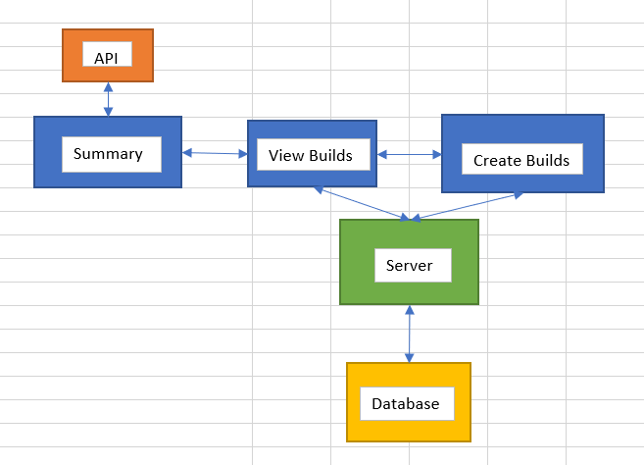

# Schedule/Gantt Chart

The four creators of this application are Steven Pellegrino, Jamin Chen, Saksham Arora, and Bobby Roche. Steven oversees the front-end development and will make the three HTML documents and their interactions with the API and the server. Saksham and Bobby are working on the server-side development and will handle their interactions with the client and database. Jamin is in charge of the back-end development and will create and populate the database as well as contribute to its interactions with the server. At the time of writing, the Summary page is functionally complete, requiring only aesthetic changes, and the other parts are well underway.

# SQL Schema

*\*Insert*

# Screenshots

